Newburgh, Fifeshire in 1836

In 1836 four of our families were living in High Street, Newburgh:
- Henry Norrie and Ann Cochrane married in 1815 and had 6 children in 1836, aged between 2 and 20. The Henry and Ann married in Errol in 1815 and the family moved to Newburgh from Errol before 1836. Henry was a slater and the eldest daughter Margaret married Alexander Marshall a hand loom weaver in 1838.
- William Scott Marshall and Jean Morice were the parents of Alexander Marshall. William was a joiner or wright born in Newburgh. They married in 1814 and in 1836 they lived in Newburgh and had 4 children ranging from 5 to 15.
- William Barclay and Rachel Laing were both born in Newburgh and married there in 1814. They lived all their lives in Newburgh and William was a hand loom weaver until he was over 80. In 1836 they had 4 children aged between 10 and 20.
- Margaret McLaren was the mother of James McKinlay born 1823. The child was illegitimate and we know little of his father other than his name and occupation - James McKinlay, tailor. Margaret was born in Newburgh and lived there all her life. She never married but was a housekeeper for her father and brothers and worked as a seamstress. James, who was 13 in 1836, became a handloom weaver by the time he was 23.

Newburgh in Fifeshire is located between Perth and Dundee and sits on the south side of the Tay estuary. Now (2007) it is a small, slightly shabby, country town which is a bit off the beaten track. The picture in 1836 was quite different.

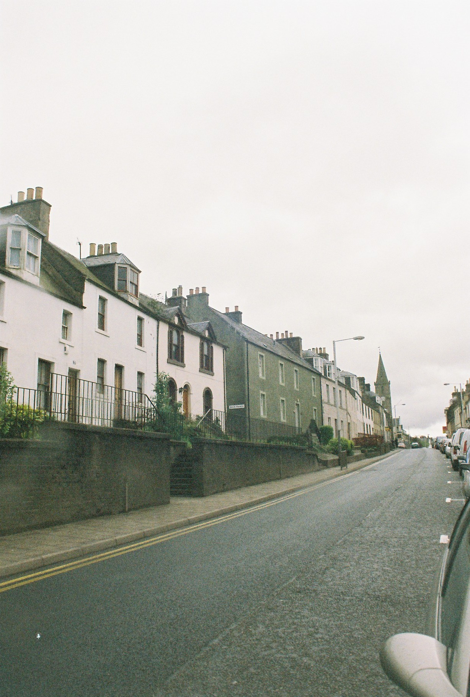
Newburgh 2007
The town is recorded in history as early as the thirteenth century and was granted a royal charter 1631 by Charles 1. By 1836 Newburgh was a busy trading centre with a very active shipping trade. As the writer of the Statistical Account (Reverend John Anderson) explained, the area had fertile well cultivated farm land, a good harbour and an abundant supply of water making Newburgh a place ‘expressly destined by nature as a place of trade’.

The Account comments that in the 50 years preceding 1836 much of the town had been rebuilt and the Church had been built in 1833. There were three piers on the shore at Newburgh and a further two had recently been completed along with dwelling houses, store-houses, granaries and other commercial buildings. A gas company had just been formed to supply gas for lighting streets and houses. The town had a daily stage coach from Perth to Kirkcaldy but there were also plans for a railway. There was a regular passenger boat from Newburgh to Pow of Errol.

The town was, by today’s standards little more than a large village. The population was 2,600 but it had grown from only 1,300 in 1755. Over 90% of the population lived in the town with a small and static population in the surrounding rural areas. In 1836 there were 530 families with an average of 5 children per family. In the 3 years from 1833 to 1836 there had been 9 illegitimate births.

In the ministers view the population were generally industrious and attentive to their religious duties and the education of their children. There were parish libraries and four schools in the parish and an average of 400 children attended these although children as young as ten could be working in the weaving trades.
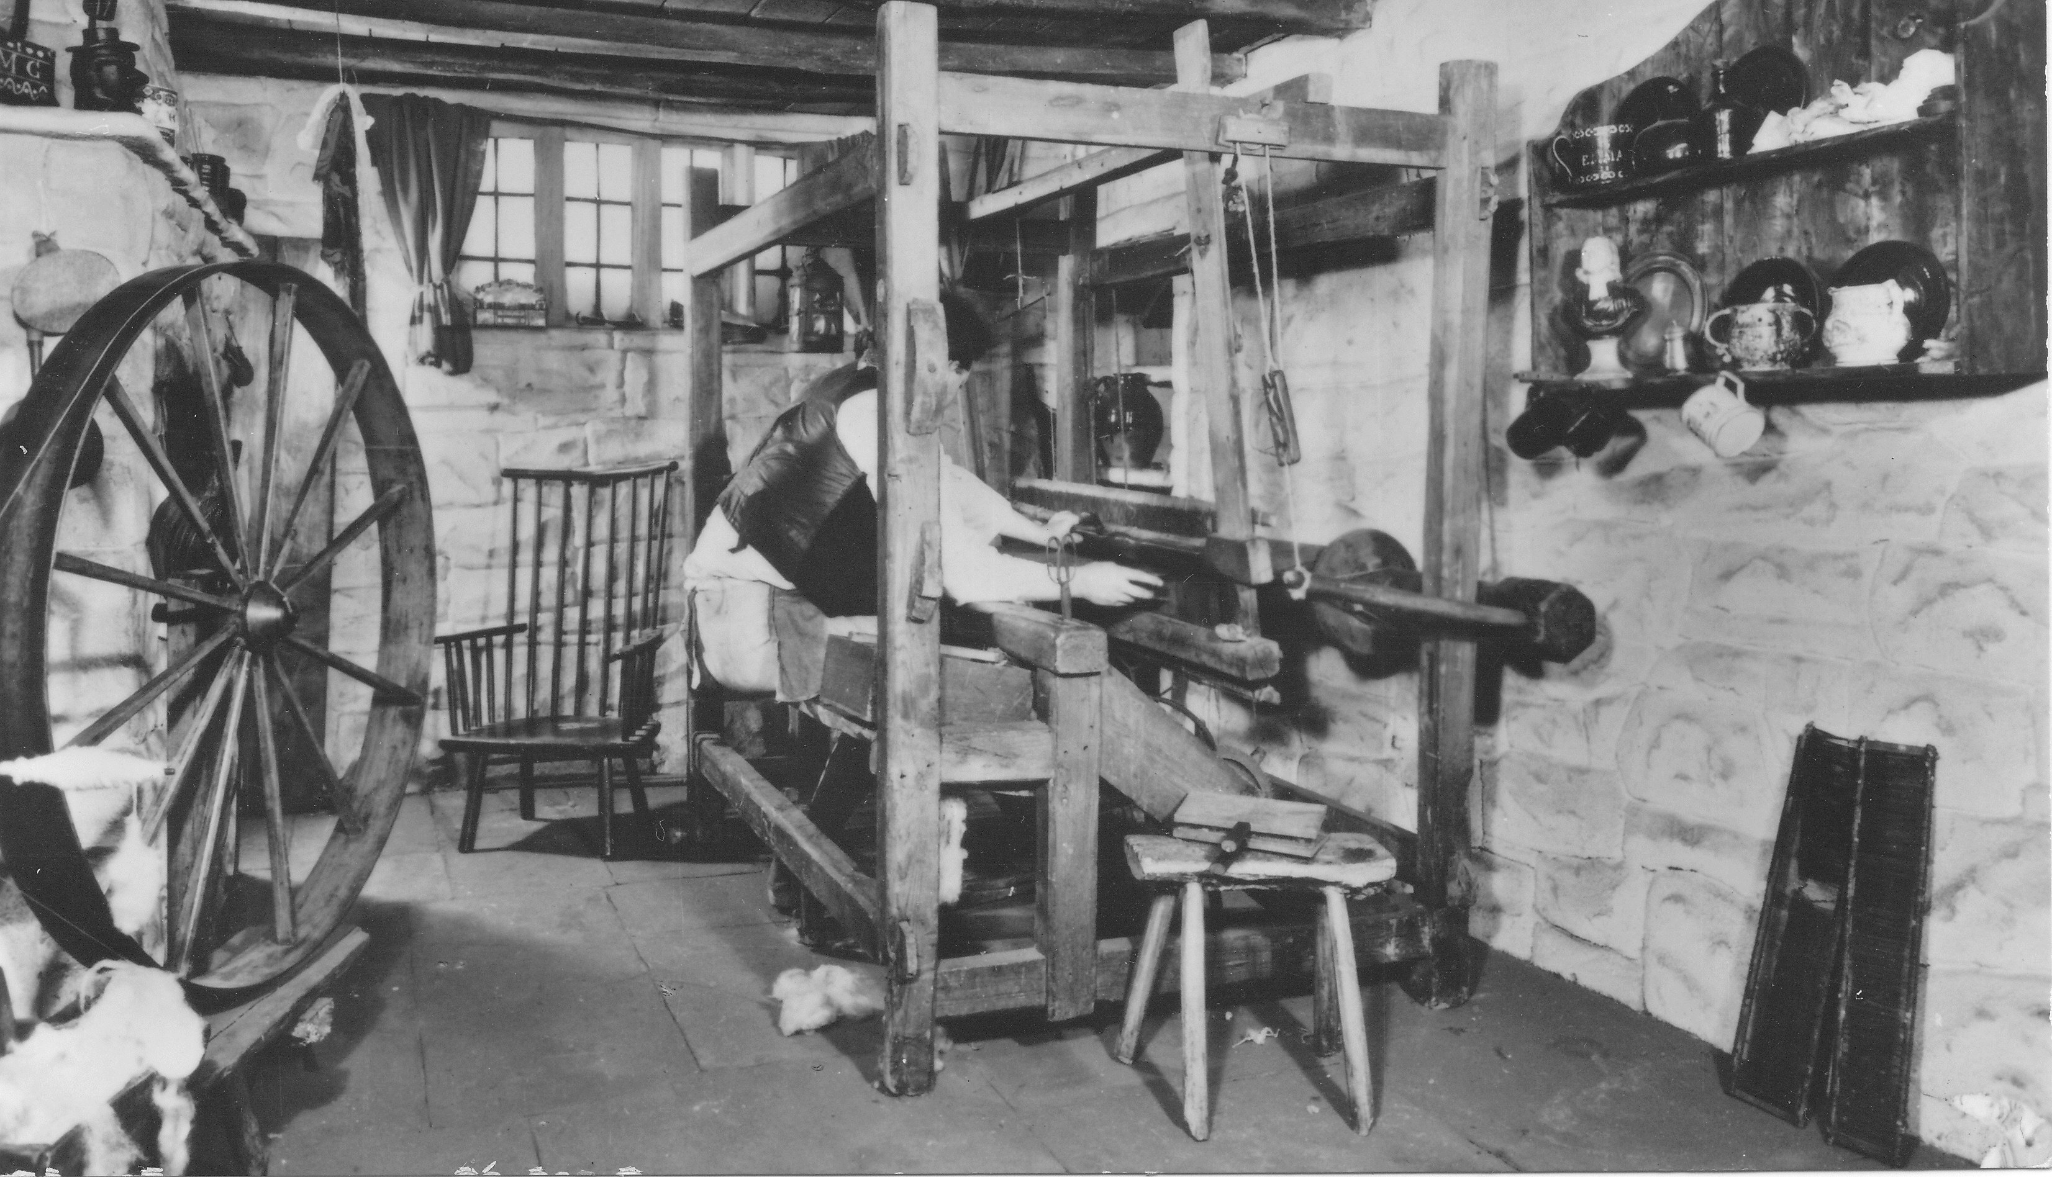
Weaving was an important part of the local economy and was viewed as the ‘principle branch of trade’ in the parish. Weavers were amongst the best paid workers of the time, receiving between 8 and 14 shillings (40p to 70p) a week dependent on their skill. They wove linen cloth which was sold to London, Leeds, and Manchester and was also exported to the West Indies and South America. At one time weavers would have woven their own yarn and traded as individuals but by 1836 the industry was controlled by thirteen masters who employed all of the weavers in the town and in the surrounding areas.
Weaver cottage 18th century

There were 560 weavers who would have worked in their home. Their work was made possible by the work undertaken by women, children and old people winding bobbins and similar supporting trades. Weavers might also be fishermen and up to 60 weavers worked as fishermen during the summer months.

The harbour was very busy - bringing the raw materials for linen weaving from Dundee and taking out the finished cloth; transporting coal to Newburgh from the north east of England and elsewhere in Scotland; bringing in wood from America and Norway. In addition some vessels were too large to take their cargo up river to Perth and had to off-load in Newburgh.

M Smith
2008

Based on the New Statistical Account of Scotland

